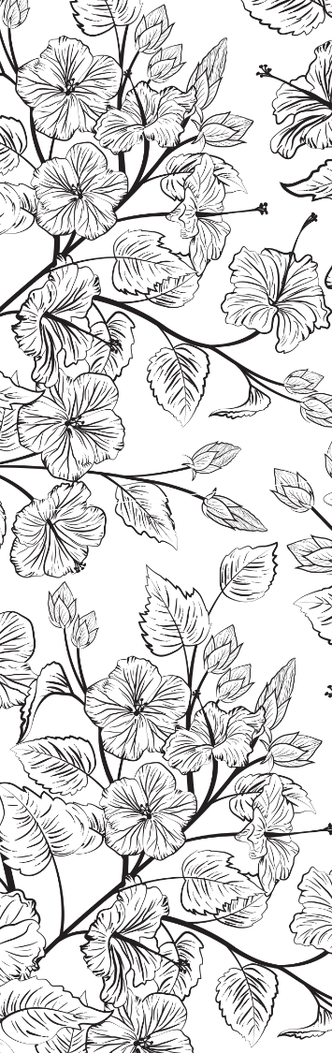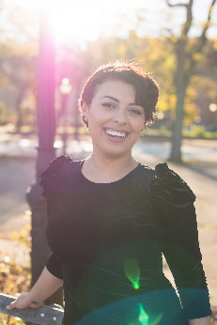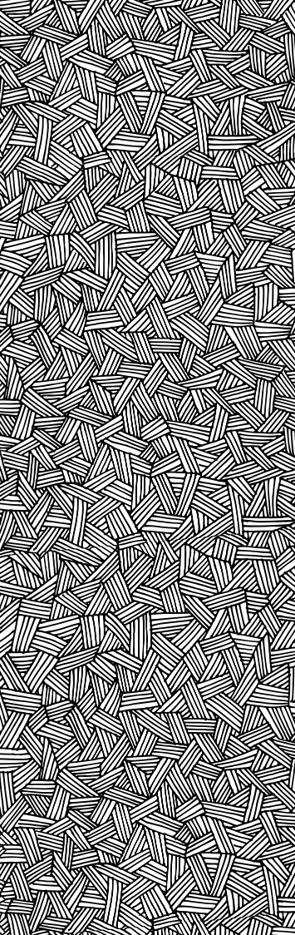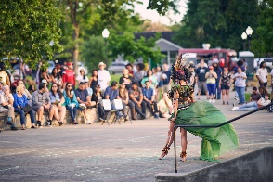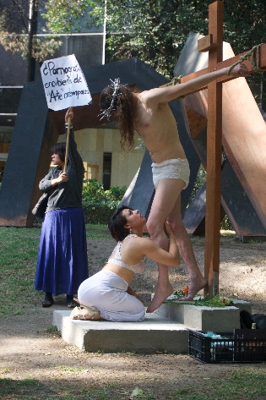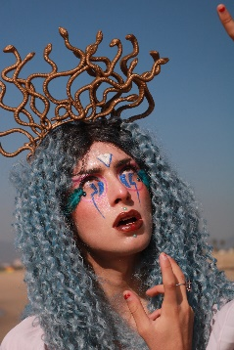

Fenix360 Interview

Press

https://youtu.be/Z17NQxPyKN8

Sacred Voice of the Bayou

Press

https://365thingsinhouston.com/sacred-voice-of-the-bayou-art-in-the-park/

El Museo de Arte Moderno.

Press https://mam.inba.gob.mx/guillermo-gomez-pena-mexican-in-documentado

Jaguars in Jumpsuits

Press

https://www.theclementecenter.org/calendar/social-collapse-cultural-syntax-art-party-l-film-premiere

Simply look up “Celestina Billington” to see more press!

 | HowlRound Theater  Press  https://howlround.com/commons/celestina-billington |  |  |  |  | Experimental Action Symposion  Press  https://www.experimentalaction.com/misson-values |  |  |  | School for the Movement of the Technicolor People  Press  https://houston.culturemap.com/eventdetail/diverseworks-school-movement-technicolor-people/ |  |  |  | The Cordial Eye Gallery Interview  Press  https://www.youtube.com/watch?v=GkUjElSY4Rs
 |  | 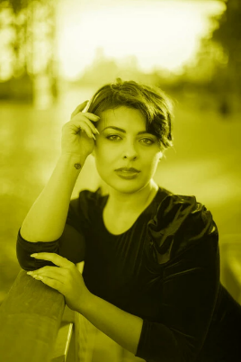 |  |  |  |  | 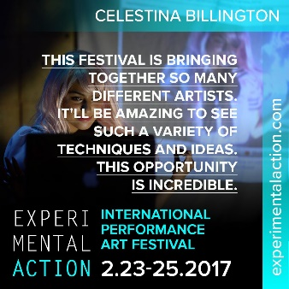 |  |  |  | 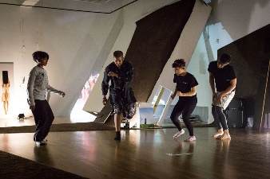 |  |  |  | 